SIMATS ENGINEERING (SAVEETHA SCHOOL OF ENGINEERING)
Department of Computer Science and Engineering

ASSESSMENT TOOL 1 – Coding Challenge Task

Course Code: | CSA06 | Course Title: | Design and Analysis of Algorithms
 | CO4: Articulation (BL4, BL5)
 |  |  | Assessment Tool 1 –  Challenge Task | Coding
CO Assessed: |  | Assessment:
 | 40% of CIA
 |  |  | 100
Weightage: |  | Total Marks:
CO4 Statement: | Solve optimization problems using dynamic progr |  | amming and greedy strateg | ies.
Student Name: | Y. Veera Reddy | Reg. No.: | 192211898
 | B Tech CSE
 |  |  | 12-08-2026
Section / Batch: |  | Date:

Instructions to Students
- Answer the following question. Total Marks: 100.
- Carefully analyze the given questions.
- Write clear code for the given problem.
- Analyze the Time complexity and Space complexity of your code using dynamic programming and greedy strategies

Question Type | Focus Area | Questions
Coding Challenge Task | Focus on Code and analyze optimization problems using dynamic programming and greedy strategies | Q1

SECTION A – Coding Challenge Task

Q1. A robber plans to steal money from houses arranged in a line, but cannot rob two adjacent houses. Each house contains a certain amount of money. The goal is to maximize the total amount of money stolen without triggering the alarm. Using Dynamic Programming, determine the maximum amount of money the robber can steal.
Input Format:
- n = number of houses
- arr[] = money values in each house

Code of Conduct
I Y. Veera Reddy / 192211898 (Name / Reg No) certify that this submission is my original work and that I have adhered to the guidelines specified for this assessment. I understand that any violation of academic integrity rules will result in disciplinary action.
Signature of the Student: Y. Veera Reddy

RUBRICS FOR CALCULATION

Coding Challenge Task

Criteria | Weightage | Level 4 (Exemplary) | Level 3 (Proficient) | Level 2 (Developing) | Level 1 (Beginning)
Problem Understanding | 20% | Clearly understands problem constraints, edge cases, and competitive requirements | Understands problem with minor gaps in constraints | Partial understanding; misses key constraints | Misinterprets problem or constraints
Algorithm | 25% | Selects optimal algorithm with best time and space complexity for  competitive constraints | Uses efficient algorithm with  minor scope for improvement | Uses basic/inefficient approach | No clear algorithmic approach
Code Implementation | 20% | Writes correct, efficient, and clean  code that passes all constraints | Code works with minor errors or inefficiencies | Partially correct code; fails for some  cases | Code does not execute or gives incorrect results
Competitive Performance | 20% | Solves problem within time limits and  handles large inputs effectively | Solves within acceptable time with minor delays | Struggles with time limits or larger inputs | Unable to solve within time constraints
Test Case Handling | 15% | Handles all test cases including edge and hidden cases | Handles most test cases | Misses important edge cases | Fails on multiple test cases

Marks Evaluation:
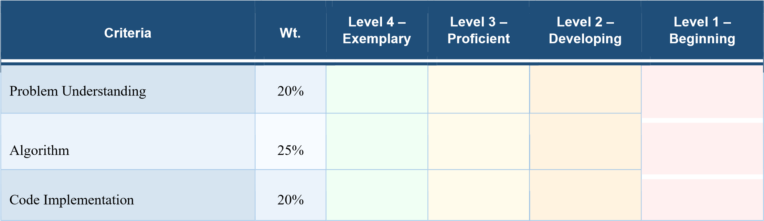
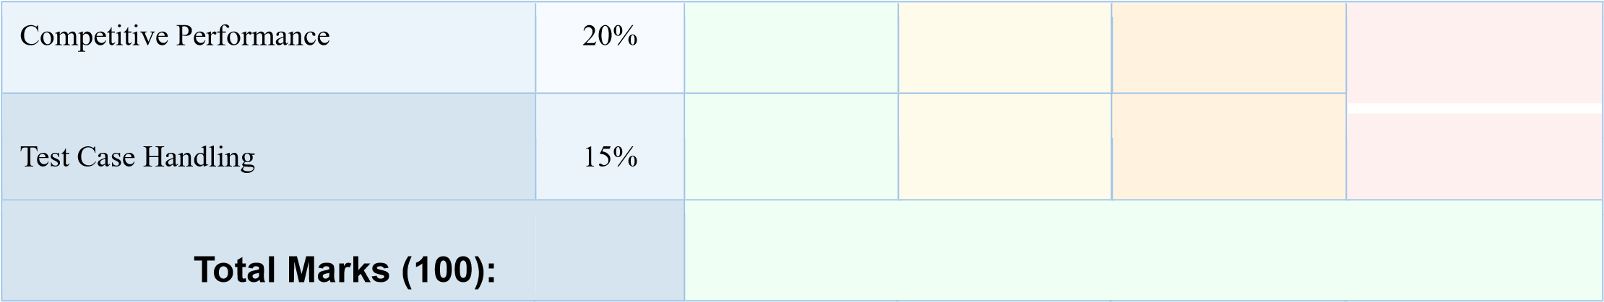

Faculty In-charge | Course Coordinator | Head of Department
Name: | Name:  Signature: _______________ | Name:  Signature: _______________  Date: ___________________
Signature: _______________
Date: ___________________ | Date: ___________________

Q1. Given an array of integers and a target sum, count the number of subsets whose sum equals the given value. Each element can either be included or excluded.

1. Problem Understanding
• The problem involves finding the total number of subsets that can be formed from a given array of integers.
• Each element in the array can either be included in a subset or excluded from it.
• The main objective is to count all possible subsets whose elements add up exactly to the given target sum.
• The input consists of the number of elements n, the array arr[], and the required target sum.
• A subset does not require the elements to be adjacent, and different selections of elements are considered as different subsets when their positions differ.
• The problem requires counting the number of valid subsets rather than finding only one subset.
• A clear understanding of the inclusion and exclusion of every element is required before designing the Dynamic Programming solution.

2. Algorithm
- The problem is solved using the Dynamic Programming (DP) technique.
- For every house, two possibilities are considered:
  - Skip the current house and keep the maximum amount obtained from the previous house.
  - Rob the current house and add its money to the maximum amount obtained up to the house before the previous one.
- The recurrence relation used is: dp[i] = max(dp[i-1], dp[i-2] + arr[i])
- The DP array stores the maximum amount that can be stolen up to each house.
- This approach avoids repeatedly solving the same subproblems and provides an efficient solution.

3. Code Implementation
- The program accepts the number of houses and the money available in each house.
- It initializes the DP array based on the first few houses.
- The program compares the amount obtained by robbing and skipping each house.
- The maximum value is stored in the DP array at every step.
- Proper conditional handling is provided for cases such as zero or one house.
- Finally, dp[n-1] gives the maximum amount of money that can be stolen.
- The implementation is simple, readable, and directly follows the Dynamic Programming algorithm.
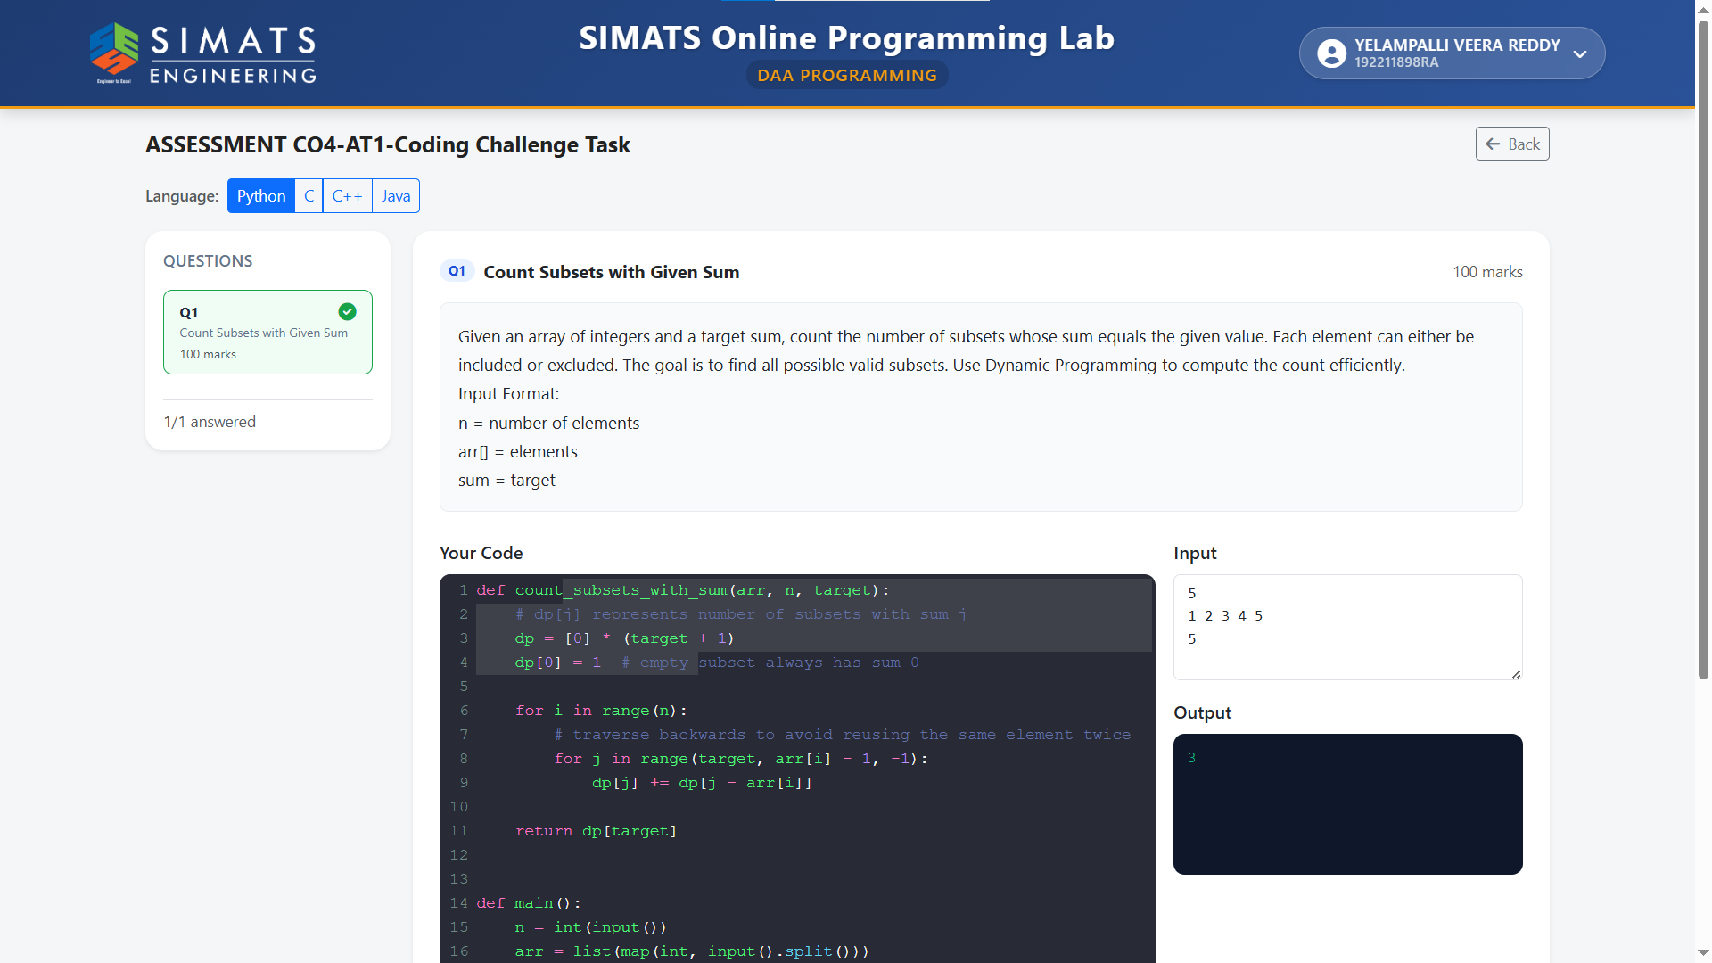

4. Competitive Performance
- The algorithm has a time complexity of O(n) because every house is processed only once.
- The space complexity is O(n) because an additional DP array is used to store intermediate results.
- It is significantly more efficient than a brute-force approach that checks every possible combination of houses.
- The solution can efficiently handle a large number of houses.
- The algorithm provides a good balance between execution time and memory usage.
- The DP approach is suitable for competitive programming because of its linear time complexity.

5. Test Case Handling
- The program handles the case when there are no houses (n = 0) by returning 0.
- For one house, the robber simply steals the amount available in that house.
- For two houses, the program selects the house containing the greater amount of money.
- For multiple houses, the program correctly chooses a combination of non-adjacent houses.
- It also handles cases where skipping a house gives a better result than robbing it.
- Different money values, including equal and varying amounts, can be tested to verify the correctness of the algorithm.
- Example: For input 2 7 9 3 1, the maximum amount is 12, obtained by selecting houses containing 2, 9, and 1.

